Cancer research: continuous changes and discoveries
Dr Momna Hejmadi lead educator of the University of Bath’s free online course ‘Inside cancer: how genes influence cancer development’ talks about the impact cancer has on the whole human population, and how daily advances in research in this field are changing the prognosis for those diagnosed with cancer around the world.

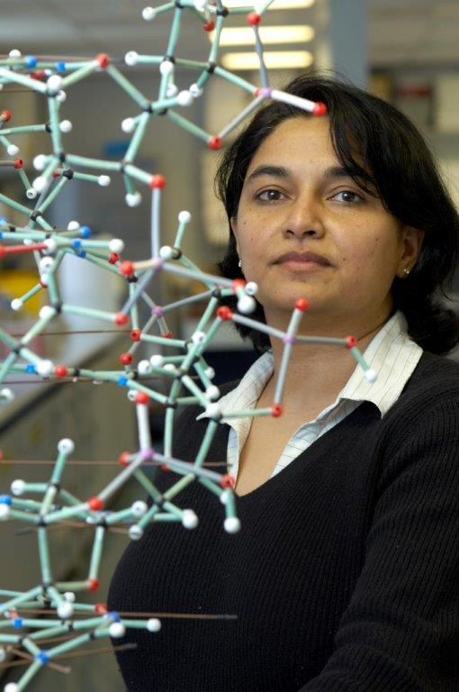
Momna Hejmadi, lead educator, University of Bath’s ‘Inside cancer: how genes influence cancer development’.

“Cancer affects about one third of our population, irrespective of nationality or ethnic origins. There is a high probability that you, or someone you know, has been affected by cancer. This is why we, at the University of Bath, see cancer as an extremely important field of research, and why we chose it as a subject for our first FutureLearn course.

“Our course is a beginner's guide to understanding how and why cancers develop and the challenges and promise of cancer therapies. There are many different types of cancer, many of which we hear of daily in the news, but also a large number that are rare and not often discussed.

“Along with my colleagues here in the Cancer Research @ Bath research network, we try to understand the molecular pathways that lead to cancer and design drugs that target these pathways.

“In fact, a new breast cancer drug pioneered here at the University, Irosustat, is currently undergoing clinical trials. The drug was designed and chemically synthesised by the Medicinal Chemistry Group in our Department of Pharmacy & Pharmacology, and could prolong the lives of thousands of women with advanced breast cancer.

“My colleagues and I hope to share some of our knowledge with you during this six-week free online course on FutureLearn.com, ‘Inside cancer: how genes influence cancer development’. This is a field in which there are changes every day, with new discoveries continually being made.

“It is also a field which we should all care about. Cancer has a huge impact on the lives of those it affects, and every step we take towards quicker diagnoses, better treatments and cures is a step in the right direction.

“Whatever your motivation to learn about cancer, join us and we’ll share some of the latest research and thinking from experts in this field with you. We really look forward to meeting you through our first FutureLearn course.”

